**TABLES:**

ZTRAVEL_FLIGHT – Reference -/dmo/travel_m – Table for Managing Travel Data

ZBOOKING_FLIGHT -Reference -/dmo/booking_m - Table for Managing Booking Data

ZBOOKING_SFLIGHT – Reference- /dmo/booksuppl_m- Table for Managing Booking Supplement Data

List Page with Create, Delete, Edit options via managed scenario.

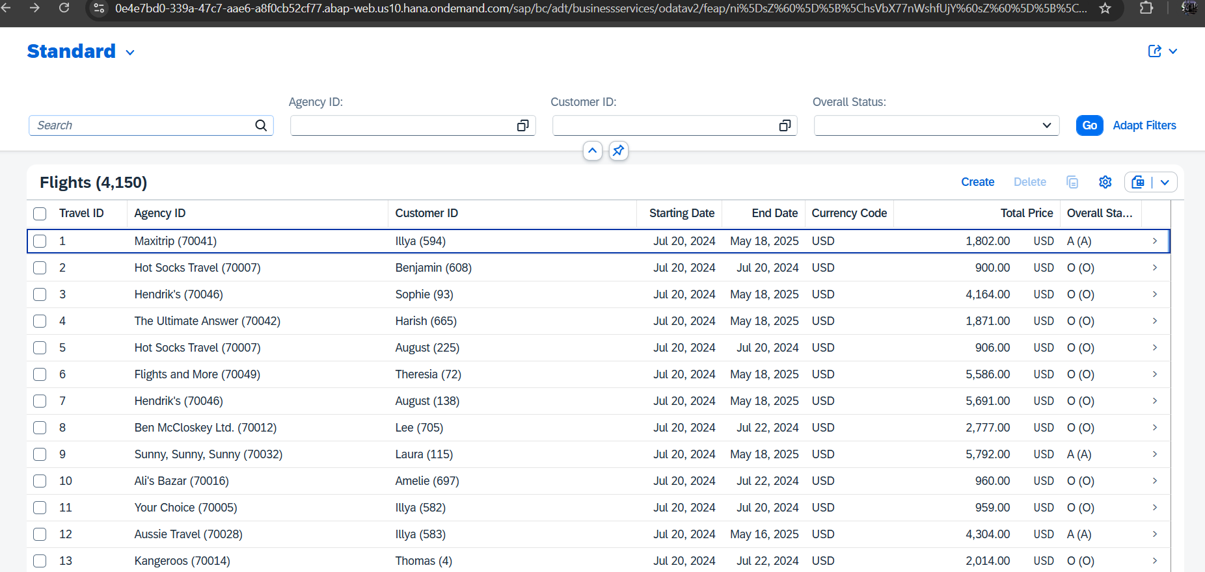

Object Page.

